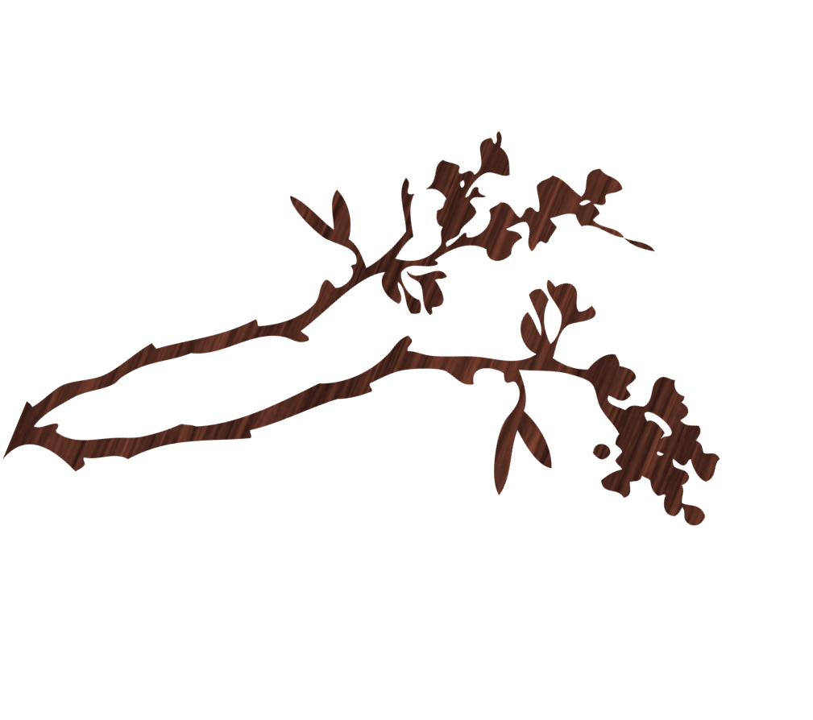
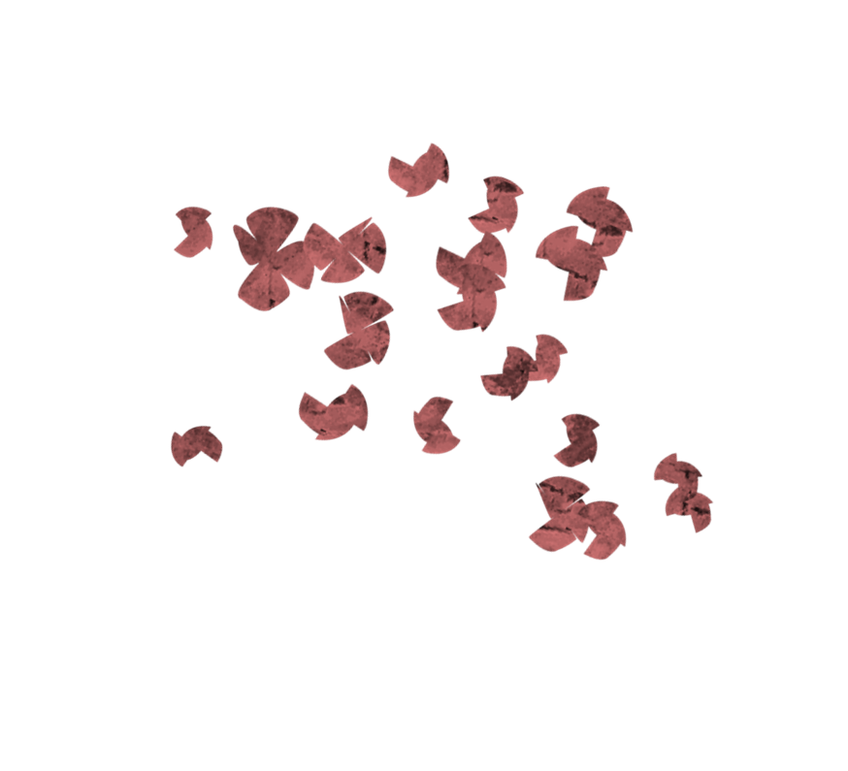
For more information or to RSVP please contact:
Ann @705-384-1892 or email - Dewey1an@live.ca

Almaguin highlands Arts Council

Strategic planning day

9:00 a.m. to 4:00 p.m.
(Nutritional breaks and lunch will be provided)
Location: Caswell Resort, Sundridge
This day will present the opportunity for AHAC members to express what are the factors or conditions which will contribute to the future success of arts in the Almaguin Highlands and the Almaguin Highland Arts Council.
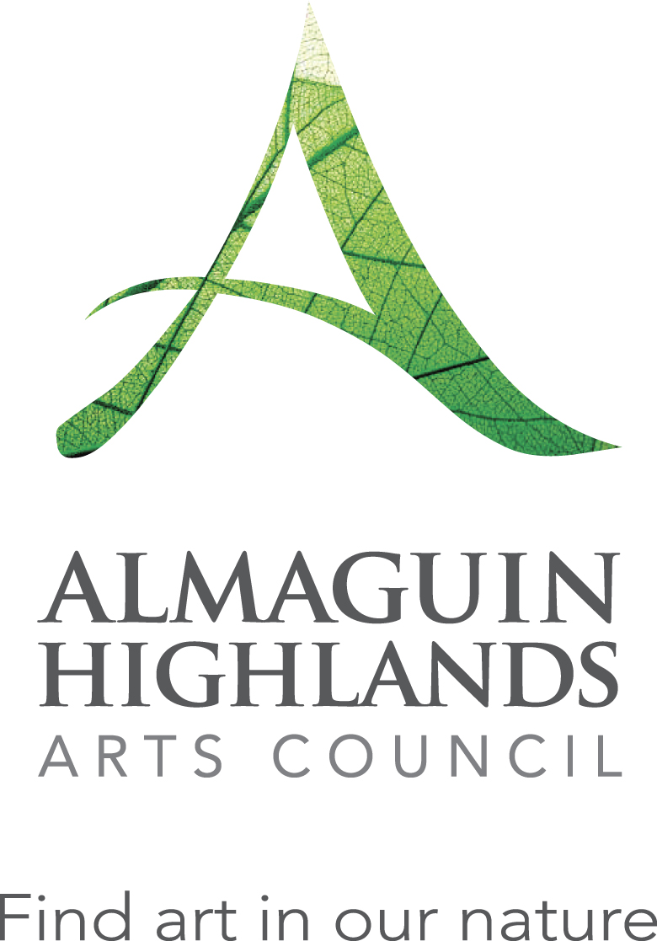
Please RSVP by April 8th so we know how many lunches to order.

